**Figure 1. Forest plot: Lifetime comorbidity between broadly-defined mood disorder and drug dependence (unadjusted)**

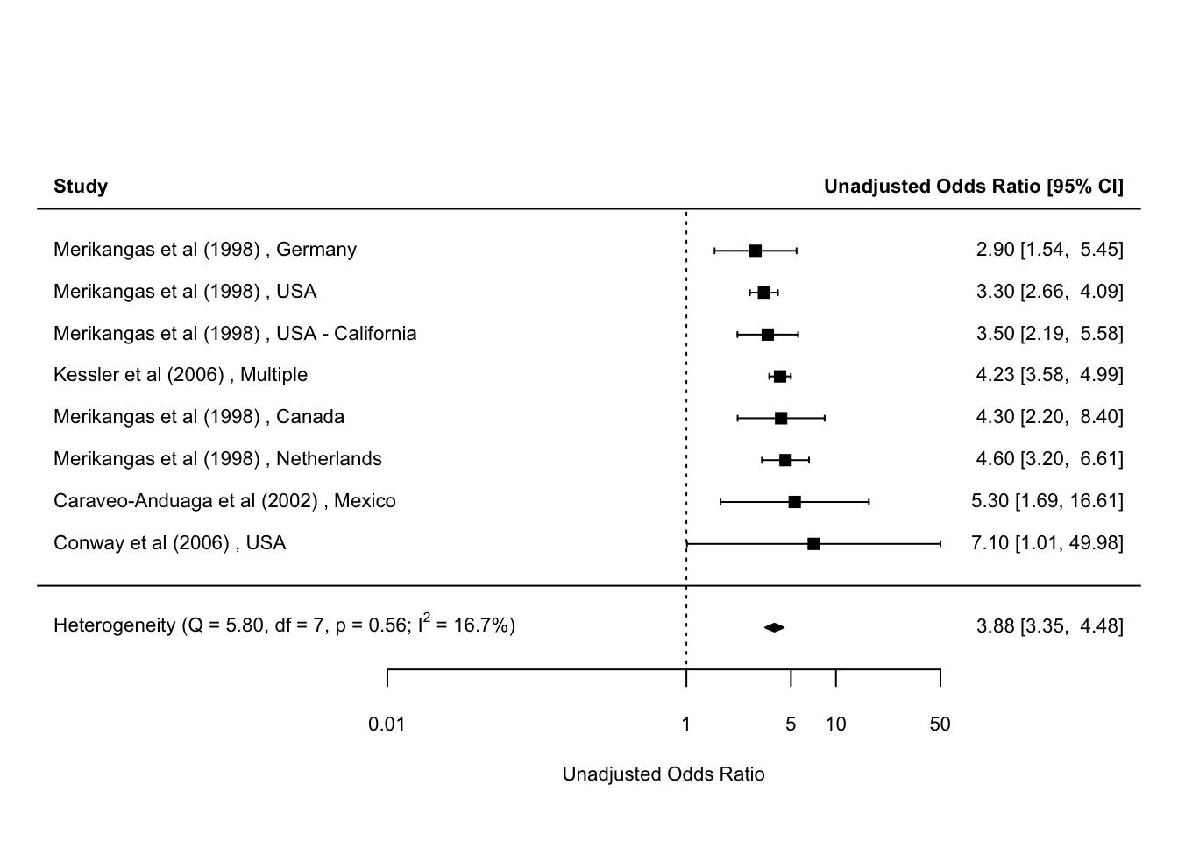

**Figure 2. Forest plot: Period prevalence comorbidity between broadly-defined depression and alcohol dependence (unadjusted)**

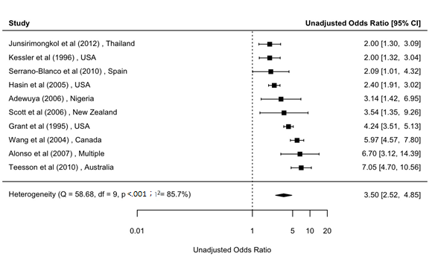

**Figure 3. Forest plot: Lifetime comorbidity between broadly-defined depression and alcohol use disorder (adjusted)**

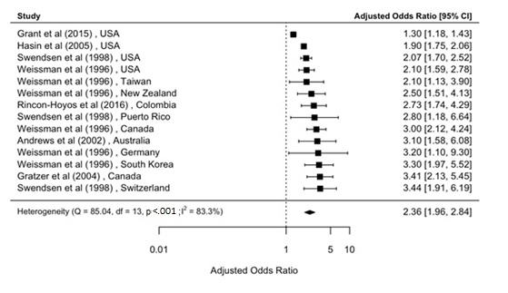

### Figure 4. Forest plot: Period prevalence comorbidity between broadly-defined mood disorder and alcohol abuse (unadjusted)

### Figure 5. Forest plot: Period prevalence comorbidity between broadly-defined mood disorder and alcohol abuse (adjusted)

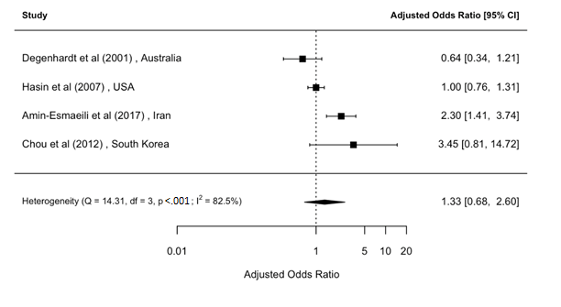

### Figure 6. Forest plot: Lifetime comorbidity between broadly-defined mood disorder and alcohol dependence (Unadjusted)

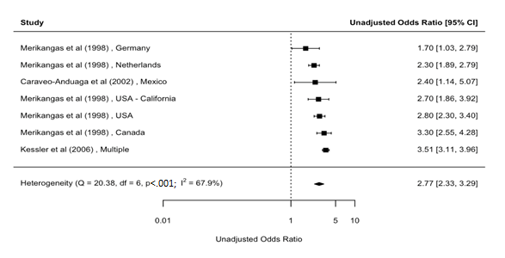

### Figure 7. Forest plot: Lifetime comorbidity between broadly-defined mood disorder and alcohol dependence (adjusted)

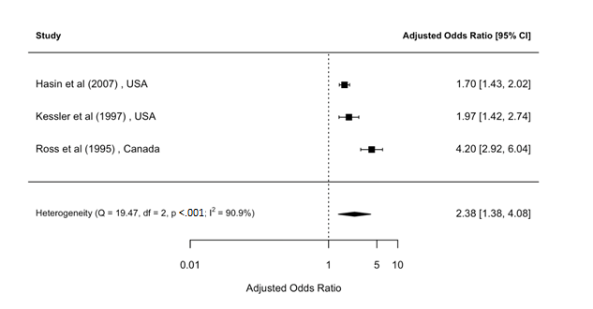

### Figure 8. Forest plot: Period prevalence comorbidity between broadly-defined mood disorder and alcohol dependence (unadjusted)

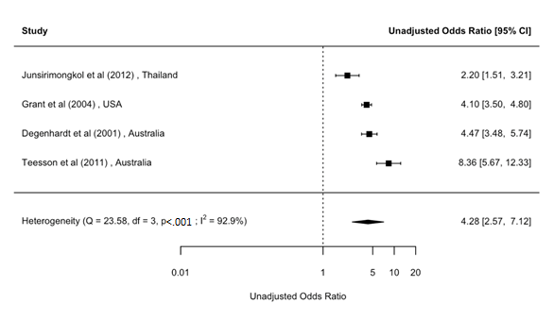

### Figure 9. Forest plot: Period prevalence comorbidity between broadly-defined mood disorder and alcohol dependence (adjusted)

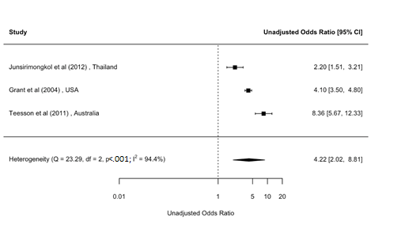

### Figure 10. Forest plot: Lifetime comorbidity between broadly-defined mood disorder and alcohol use disorder (unadjusted)

### Figure 11. Forest plot: Lifetime comorbidity between broadly-defined mood disorder and alcohol use disorder (adjusted)

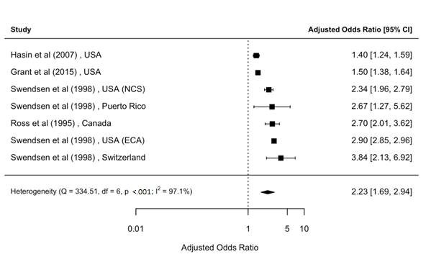

### Figure 12. Forest plot: Period prevalence comorbidity between broadly-defined mood disorder and alcohol use disorder (unadjusted)

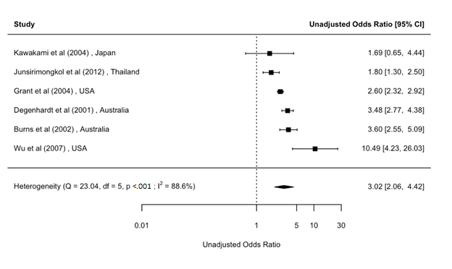

### Figure 13. Forest plot: Period prevalence comorbidity between broadly-defined mood disorder and alcohol use disorder (adjusted)

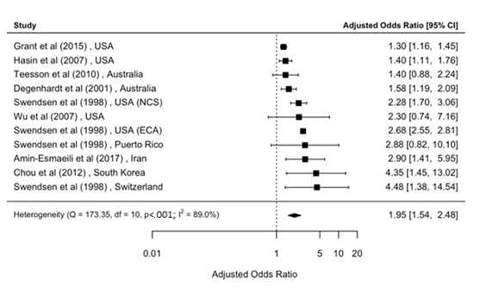

### Figure 14. Forest plot: Lifetime comorbidity between broadly-defined mood disorder and drug abuse (unadjusted)

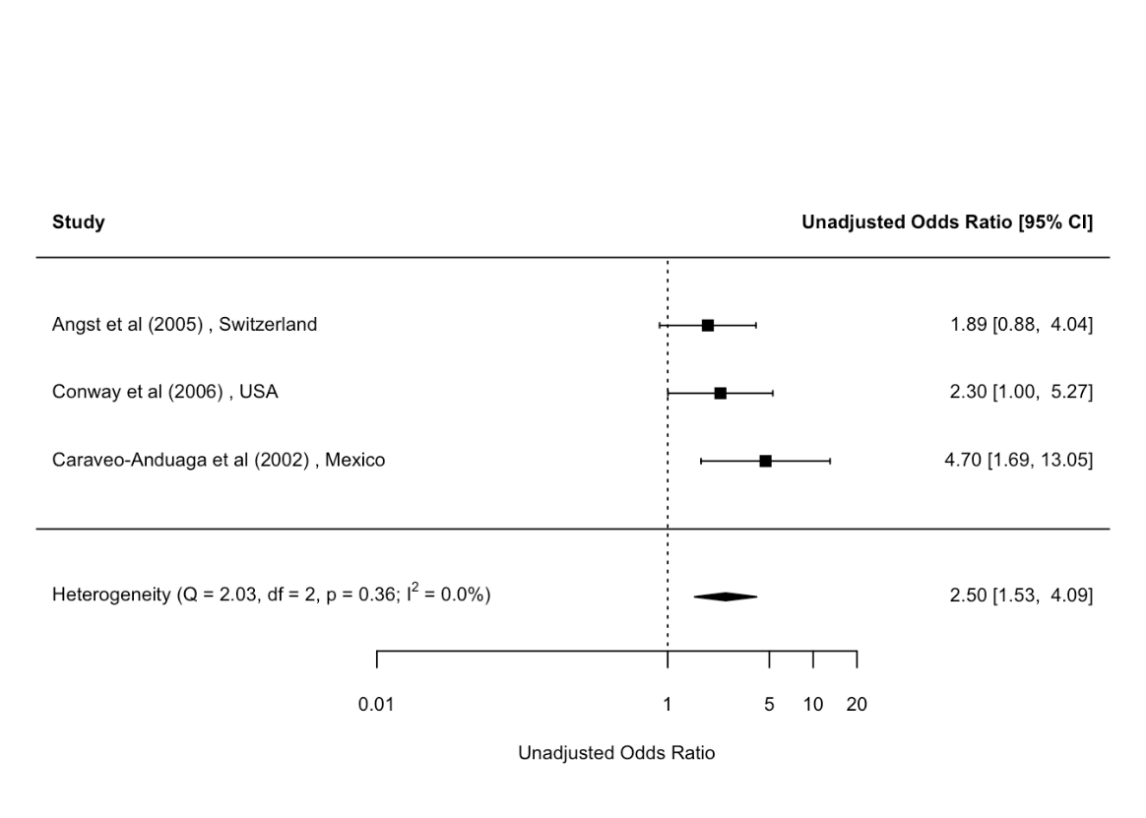

### Figure 15. Forest plot: Period prevalence comorbidity between broadly-defined mood disorder and drug use disorder (adjusted)

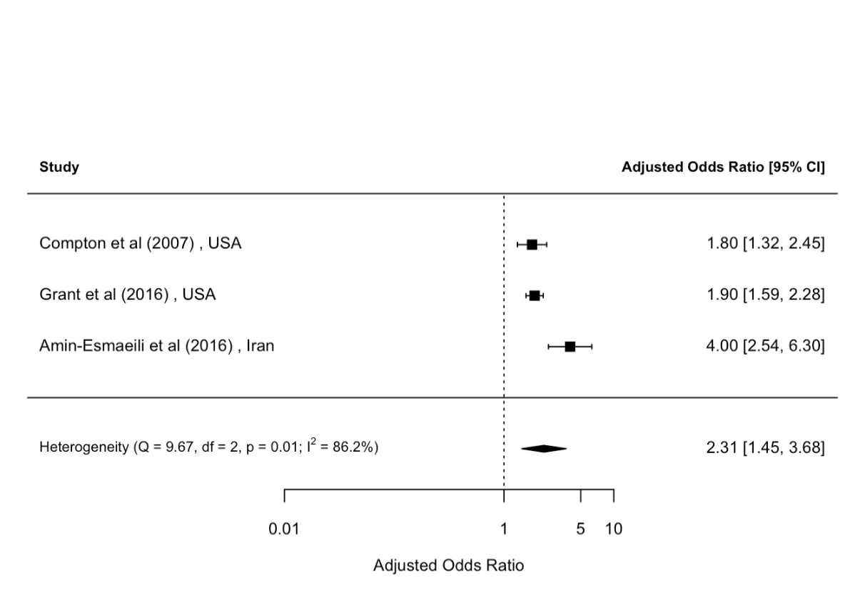

### Figure 16. Forest plot: Period prevalence comorbidity between broadly-defined mood disorder and substance use disorder (unadjusted)

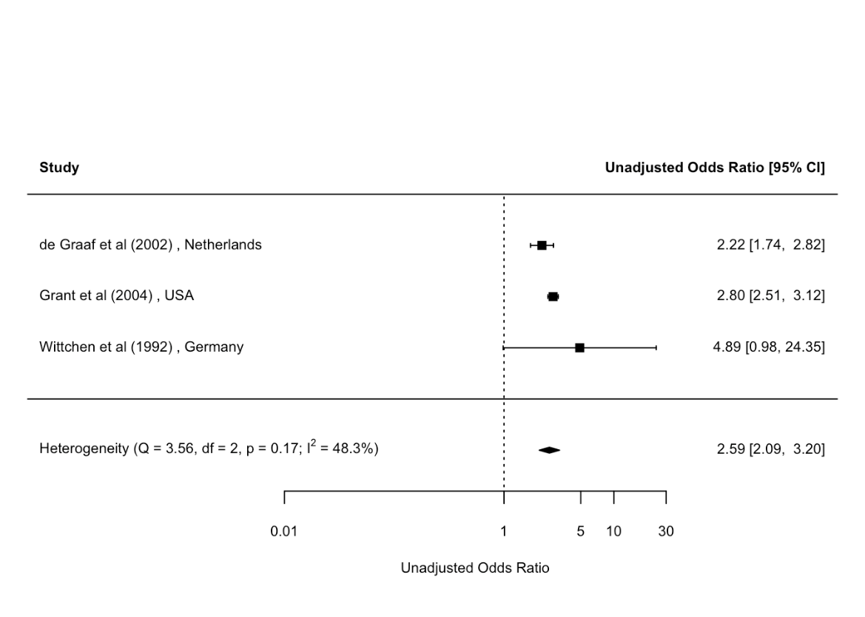

### Figure 17. Forest plot: Period prevalence comorbidity between broadly-defined dysthymia and alcohol abuse (unadjusted)

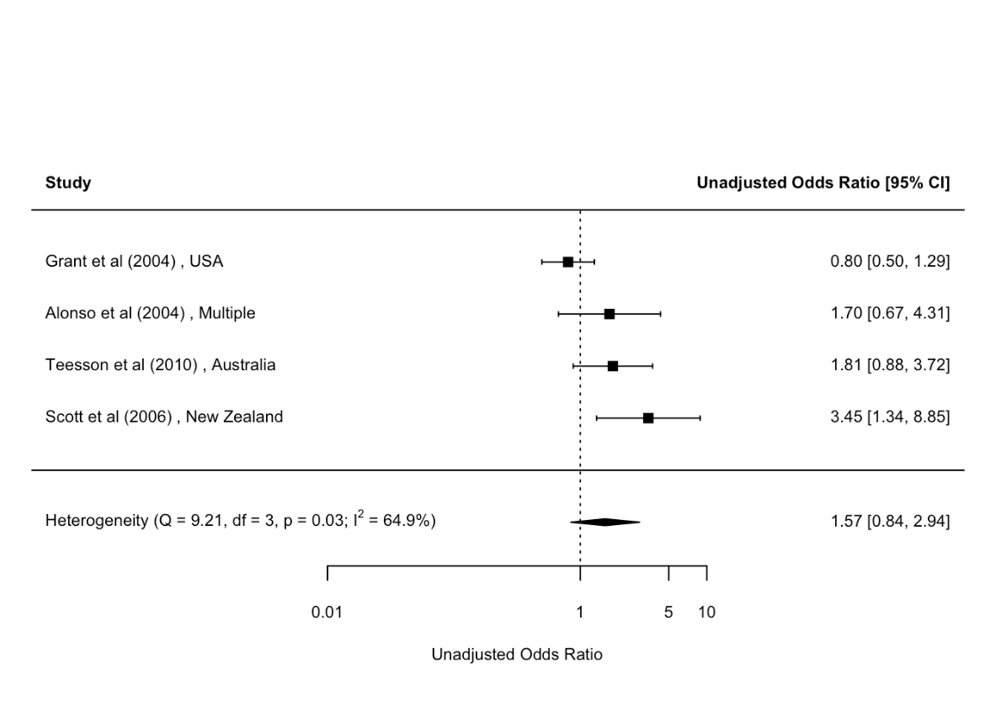

### Figure 18. Forest plot: Lifetime comorbidity between broadly-defined dysthymia and alcohol dependence (unadjusted)

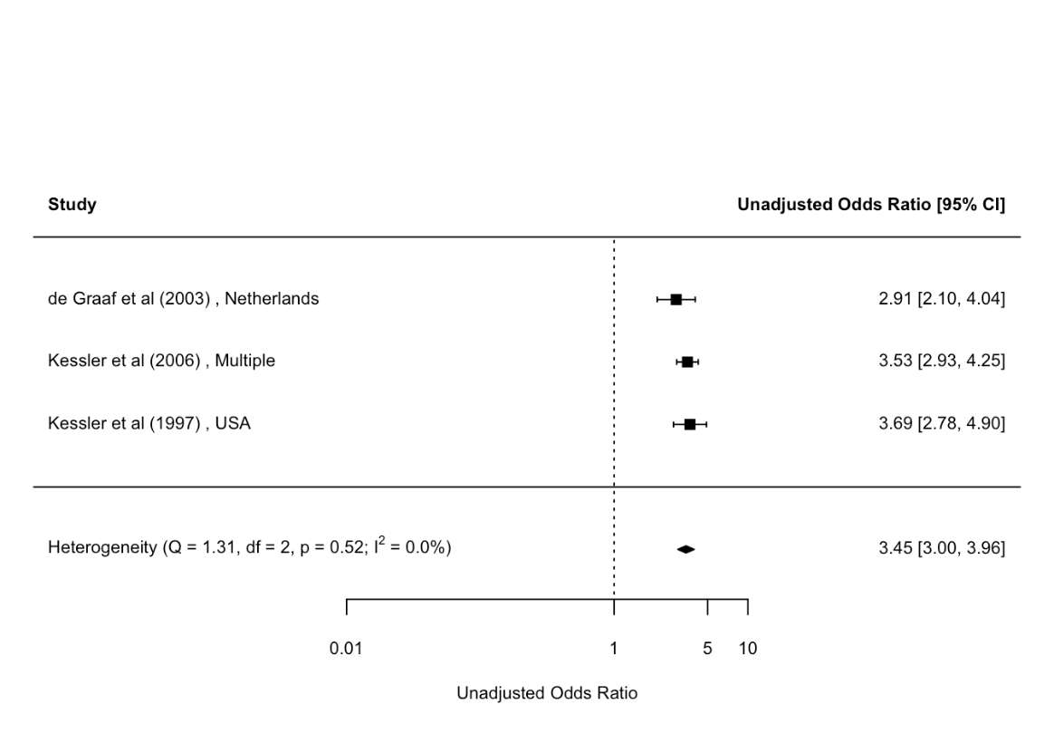

Figure 19. Forest plot: Lifetime comorbidity between broadly-defined dysthymia and alcohol dependence (adjusted)

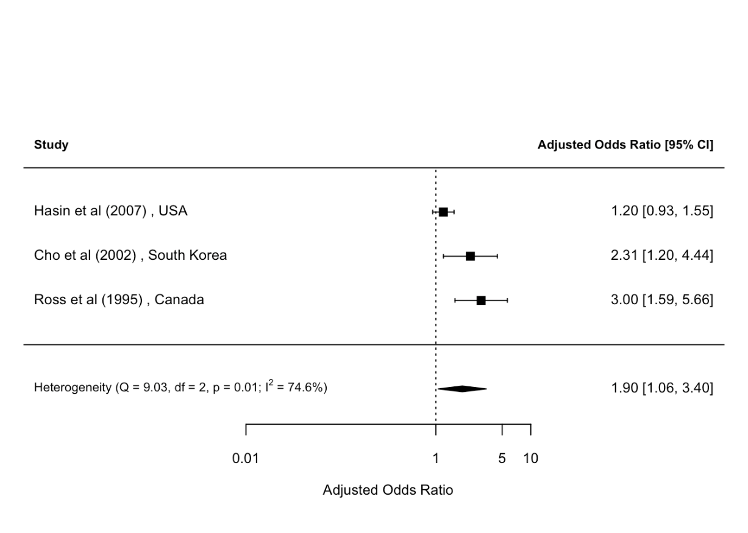

### Figure 20. Forest plot: Period prevalence comorbidity between broadly-defined dysthymia and alcohol dependence (unadjusted)

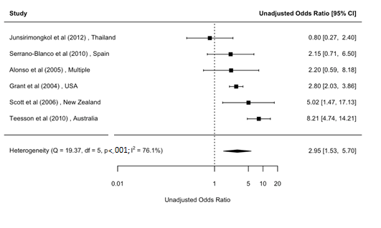

### Figure 21. Forest plot: Lifetime comorbidity between broadly-defined dysthymia and alcohol use disorder (unadjusted)

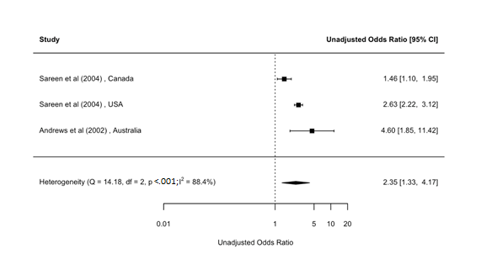

### Figure 22. Forest plot: Lifetime comorbidity between broadly-defined dysthymia and alcohol use disorder (adjusted)

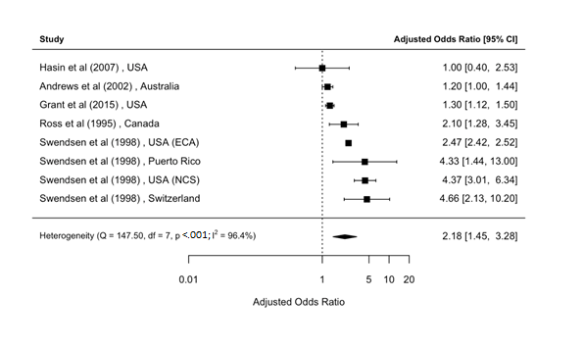

### Figure 23. Forest plot: Period prevalence comorbidity between broadly-defined dysthymia and alcohol use disorder (unadjusted)

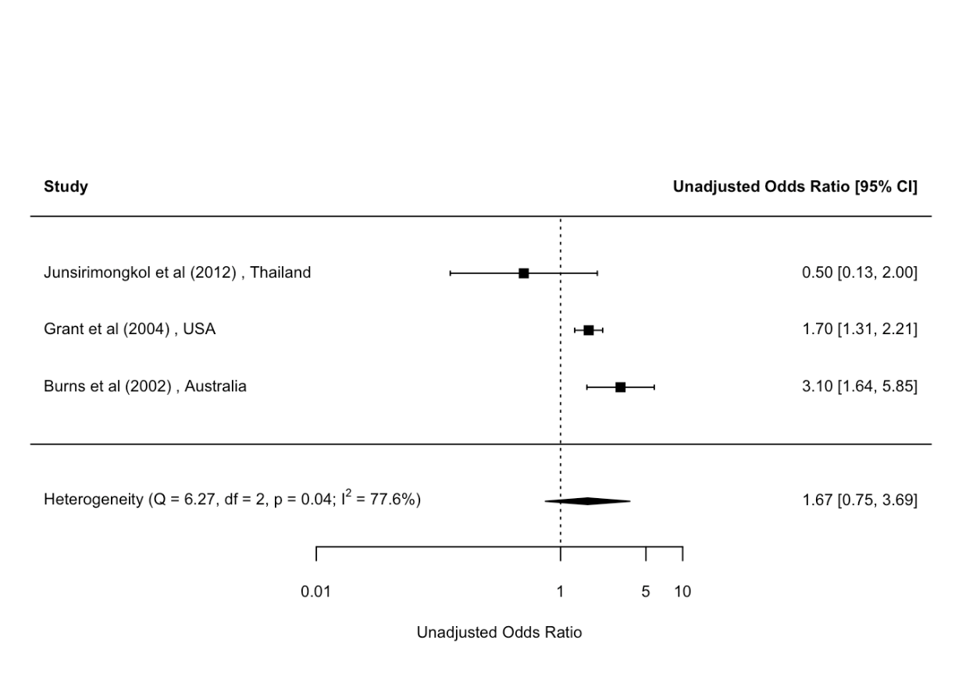

### Figure 24. Forest plot: Period prevalence comorbidity between broadly-defined dysthymia and alcohol use disorder (adjusted)

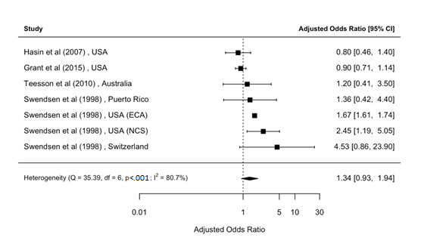

### Figure 25. Forest plot: Lifetime comorbidity between broadly-defined dysthymia and drug dependence (unadjusted)

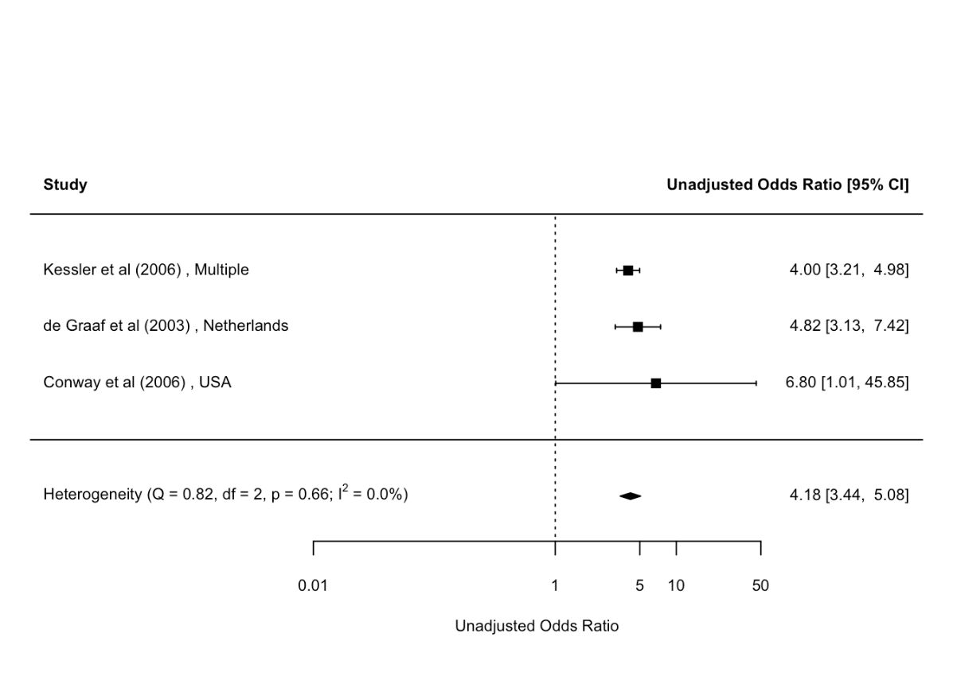

### 

### Figure 26. Forest plot: Period prevalence comorbidity between broadly-defined dysthymia and drug dependence (unadjusted)

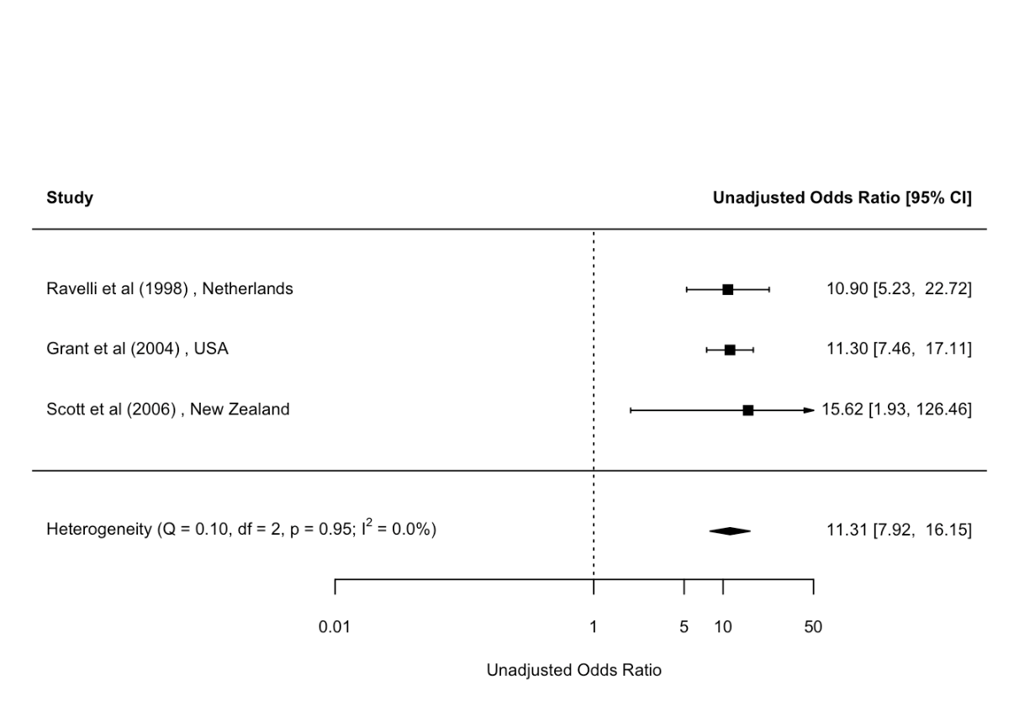

### Figure 27. Forest plot: Lifetime comorbidity between broadly-defined depression and alcohol abuse (unadjusted)

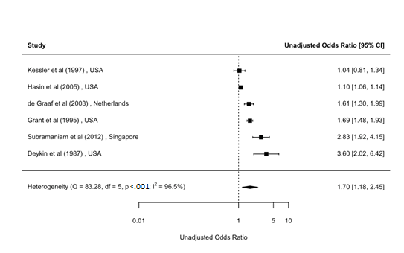

### Figure 28. Forest plot: Lifetime comorbidity between broadly-defined depression and alcohol abuse (adjusted)

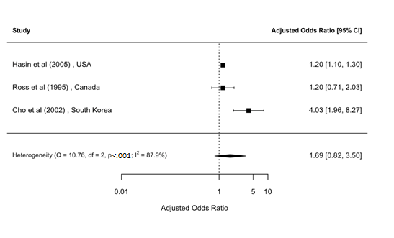

### Figure 29. Forest plot: Period prevalence comorbidity between broadly-defined depression and alcohol abuse (unadjusted)

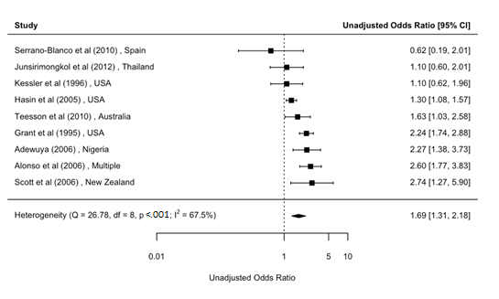

### Figure 30. Forest plot: Period prevalence comorbidity between broadly-defined depression and alcohol abuse (adjusted)

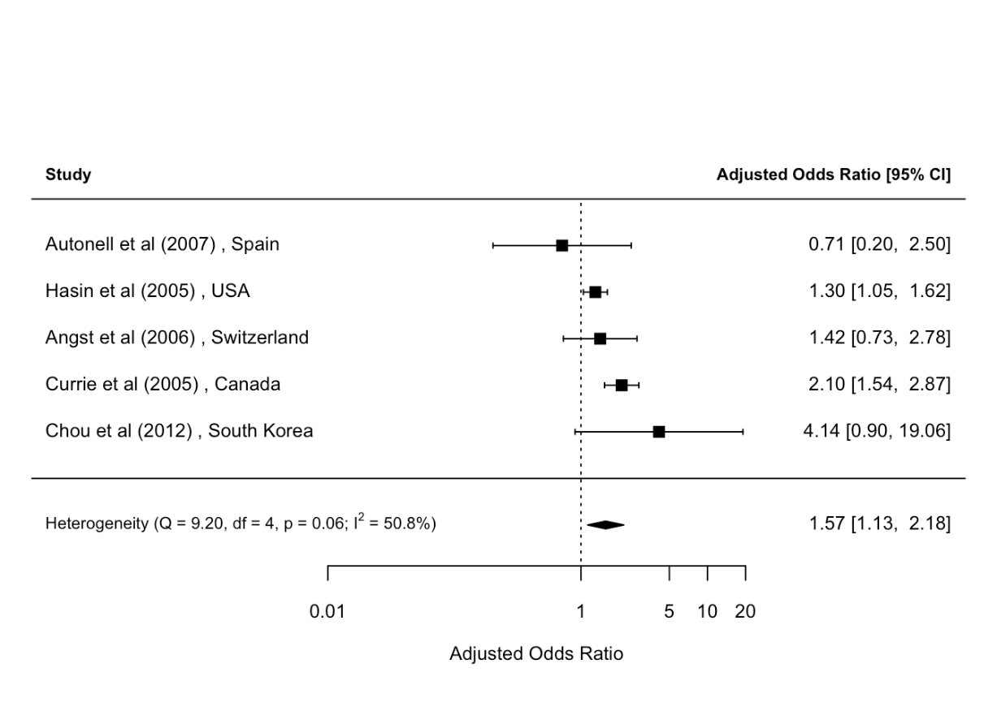

### Figure 31. Forest plot: Lifetime comorbidity between broadly-defined depression and alcohol dependence (unadjusted)

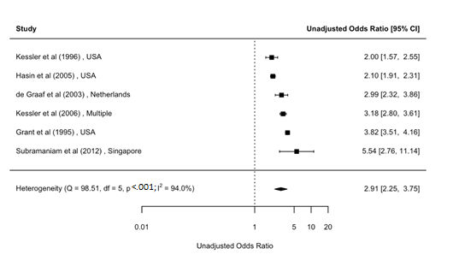

### Figure 32. Forest plot: Lifetime comorbidity between broadly-defined depression and alcohol dependence (adjusted)

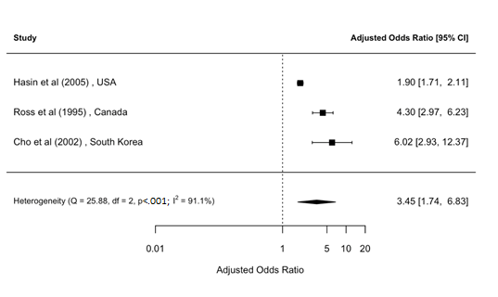

### Figure 33. Forest plot: Period prevalence comorbidity between broadly-defined depression and alcohol dependence (adjusted)

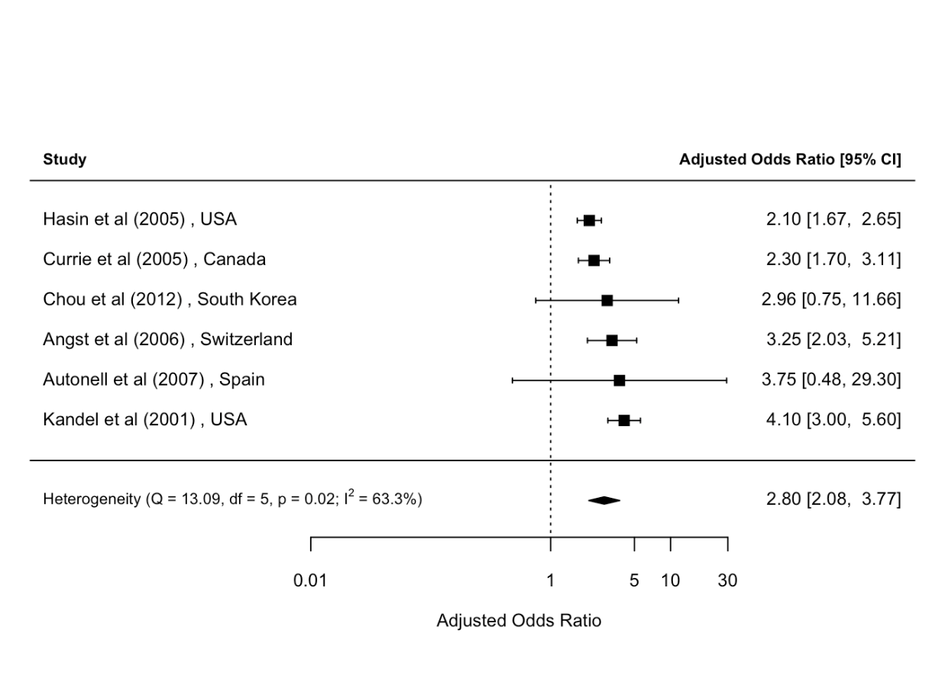

### Figure 34. Forest plot: Lifetime comorbidity between broadly-defined depression and alcohol use disorder (unadjusted)

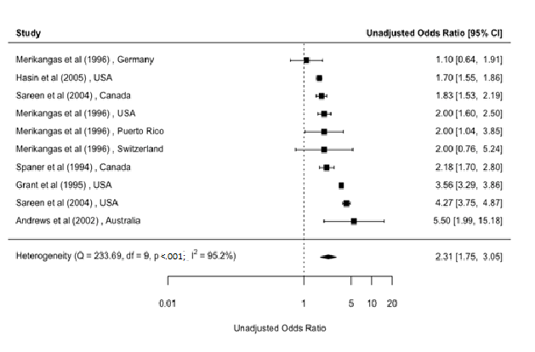

### Figure 35. Forest plot: Period prevalence comorbidity between broadly-defined depression and alcohol use disorder (unadjusted)

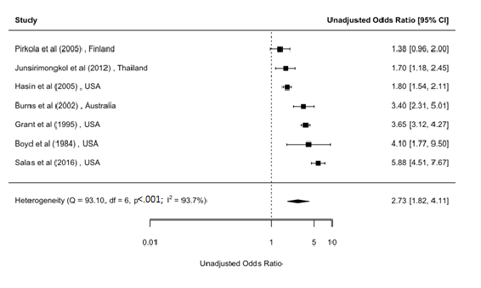

### Figure 36. Forest plot: Period prevalence comorbidity between broadly-defined depression and alcohol use disorder (adjusted)

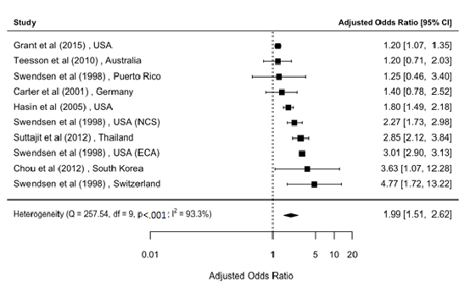

### Figure 37. Forest plot: Lifetime comorbidity between broadly-defined depression and drug abuse (unadjusted)

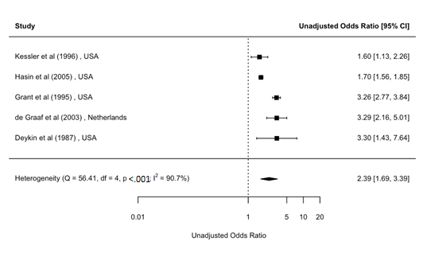

### Figure 38. Forest plot: Period prevalence comorbidity between broadly-defined depression and drug abuse (unadjusted)

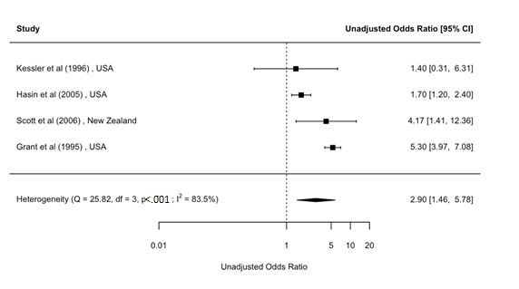

### Figure 39. Forest plot: Lifetime comorbidity between broadly-defined depression and drug dependence (unadjusted)

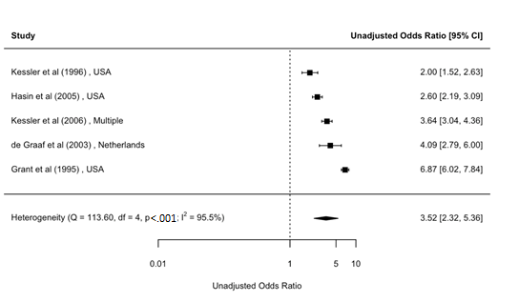

### Figure 40. Forest plot: Period prevalence comorbidity between broadly-defined depression and drug dependence (unadjusted)

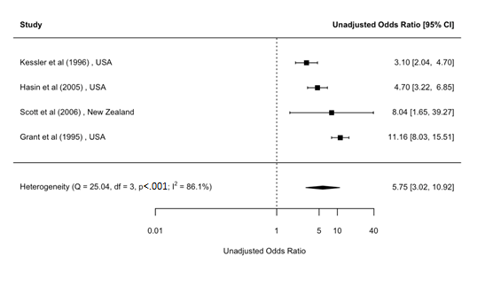

### Figure 41. Forest plot: Period prevalence comorbidity between broadly-defined depression and drug dependence (adjusted)

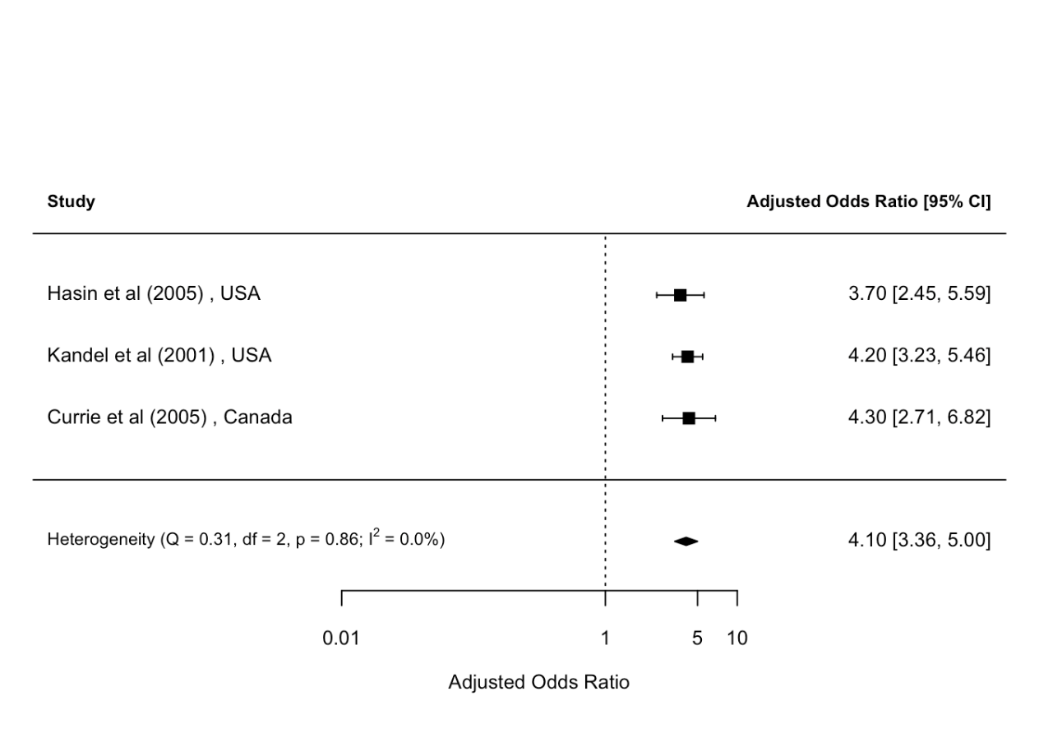

### Figure 42. Forest plot: Lifetime comorbidity between broadly-defined depression and drug use disorder (unadjusted)

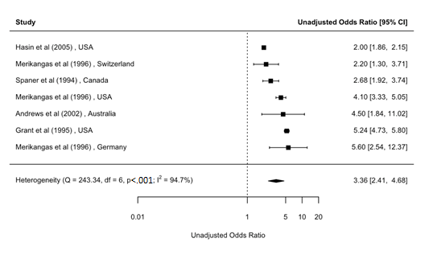

### Figure 43. Forest plot: Lifetime comorbidity between broadly-defined depression and drug use disorder (adjusted)

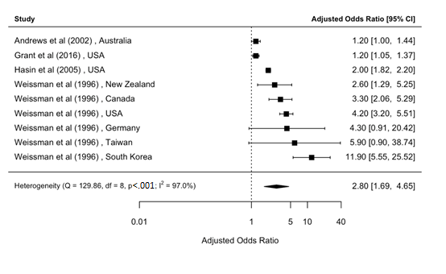

### Figure 44. Forest plot: Period prevalence comorbidity between broadly-defined depression and drug use disorder (unadjusted)

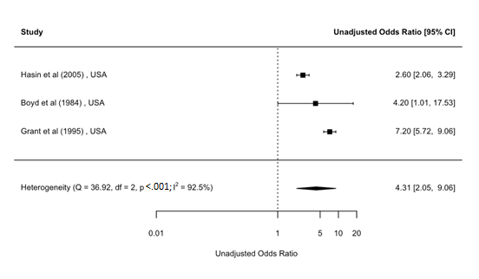

### Figure 45. Forest plot: Period prevalence comorbidity between broadly-defined depression and drug use disorder (adjusted)

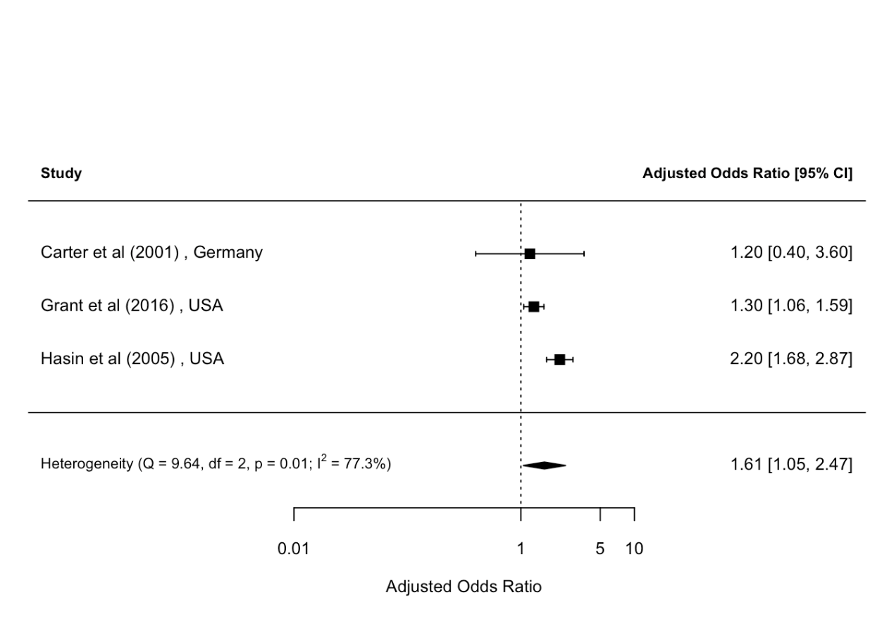

### Figure 46. Forest plot: Lifetime comorbidity between broadly-defined depression and cannabis dependence (unadjusted)

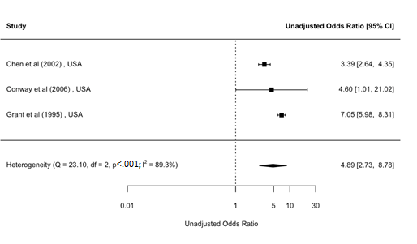

### Figure 47. Forest plot: Period prevalence comorbidity between broadly-defined depression and nicotine dependence (adjusted)

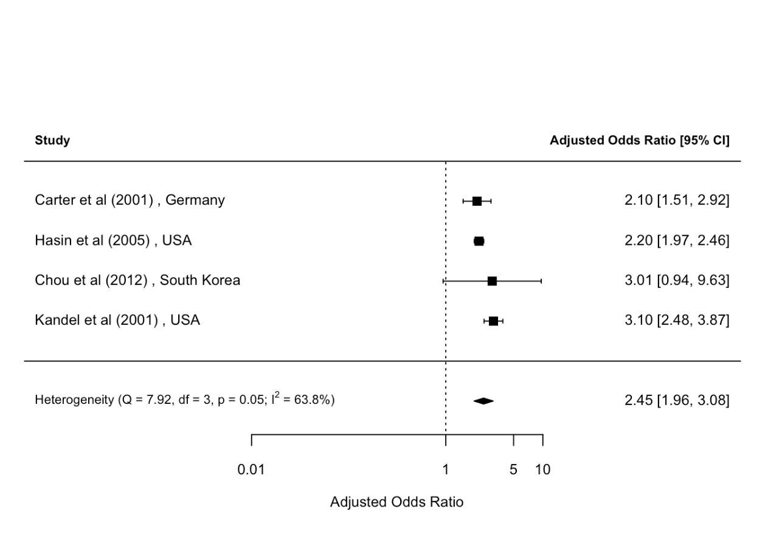

### Figure 48. Forest plot: Lifetime comorbidity between broadly-defined bipolar disorder and alcohol abuse (adjusted)

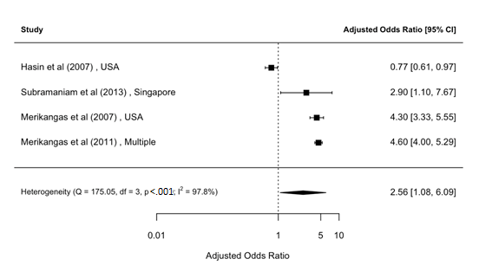

### Figure 49. Forest plot: Period prevalence comorbidity between broadly-defined bipolar disorder and alcohol abuse (adjusted)

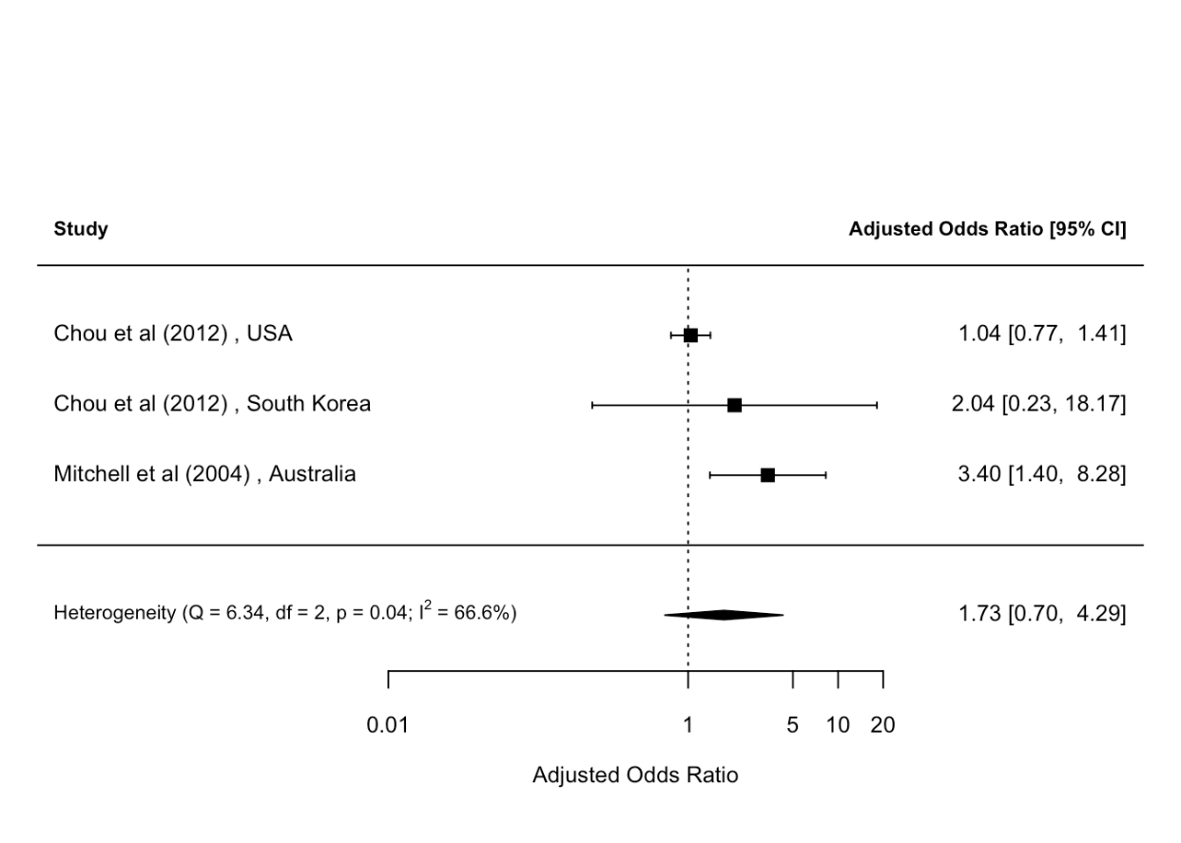

### Figure 50. Forest plot: Lifetime comorbidity between broadly-defined bipolar disorder and alcohol dependence (adjusted)

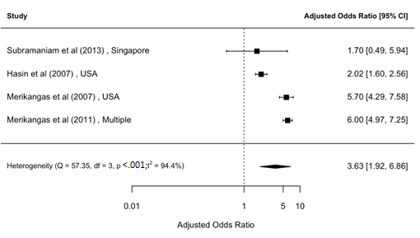

### Figure 51. Forest plot: Period prevalence comorbidity between broadly-defined bipolar disorder and alcohol use disorder (adjusted)

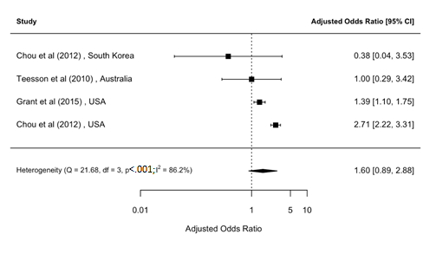

### Figure 52. Forest plot: Lifetime comorbidity between broadly-defined bipolar disorder and substance use disorder (unadjusted)

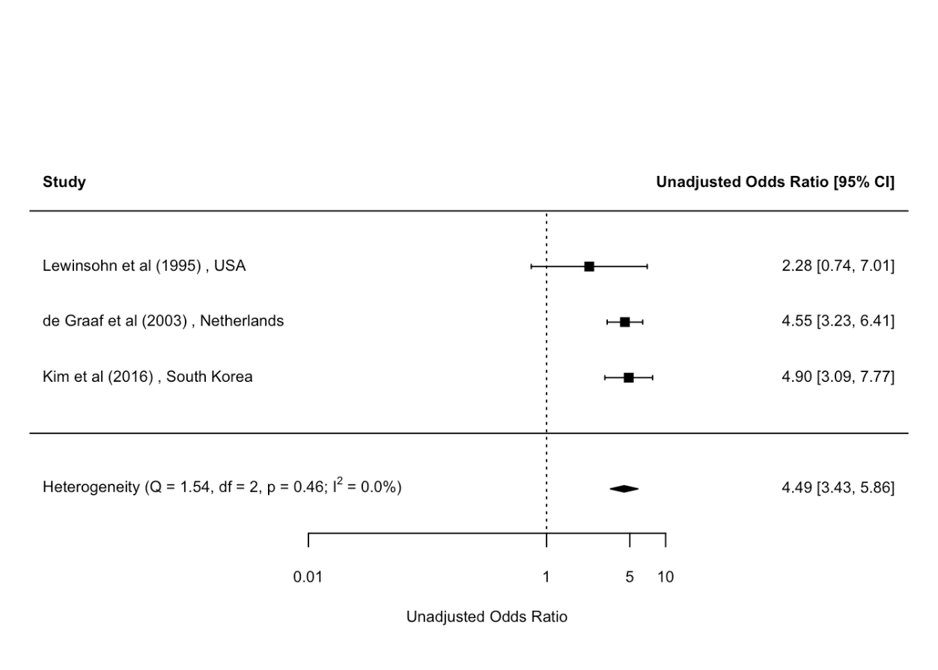

### Figure 53. Forest plot: temporally-ordered comorbidity between depression and alcohol abuse (unadjusted)

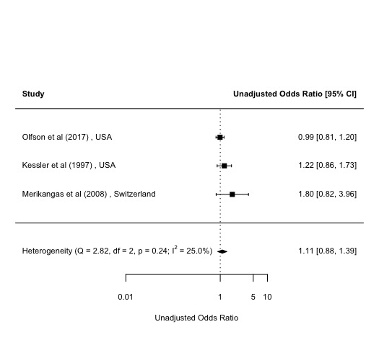

### Figure 54. Forest plot: temporally-ordered comorbidity between depression and alcohol dependence (unadjusted)

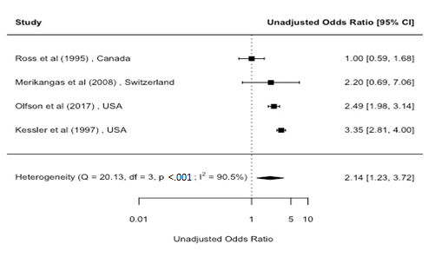

### Figure 55. Forest plot: temporally-ordered comorbidity between depression and alcohol dependence (adjusted)

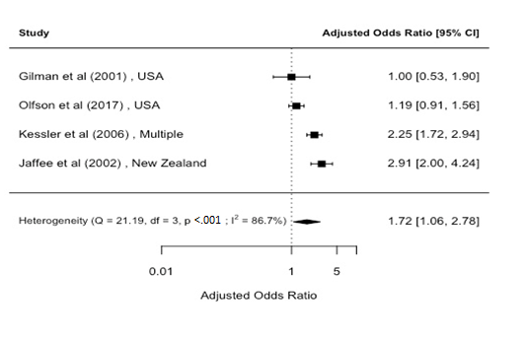

### Figure 56 . Forest plot: temporally-ordered comorbidity between alcohol use disorder and depression (adjusted)

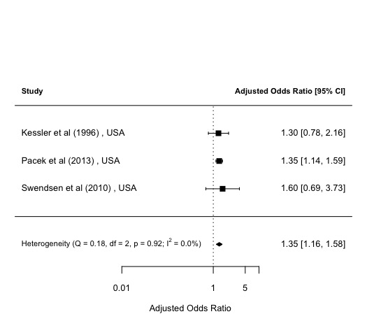

### Figure 57. Funnel plot: Period prevalence comorbidity between mood and alcohol use disorder (adjusted)

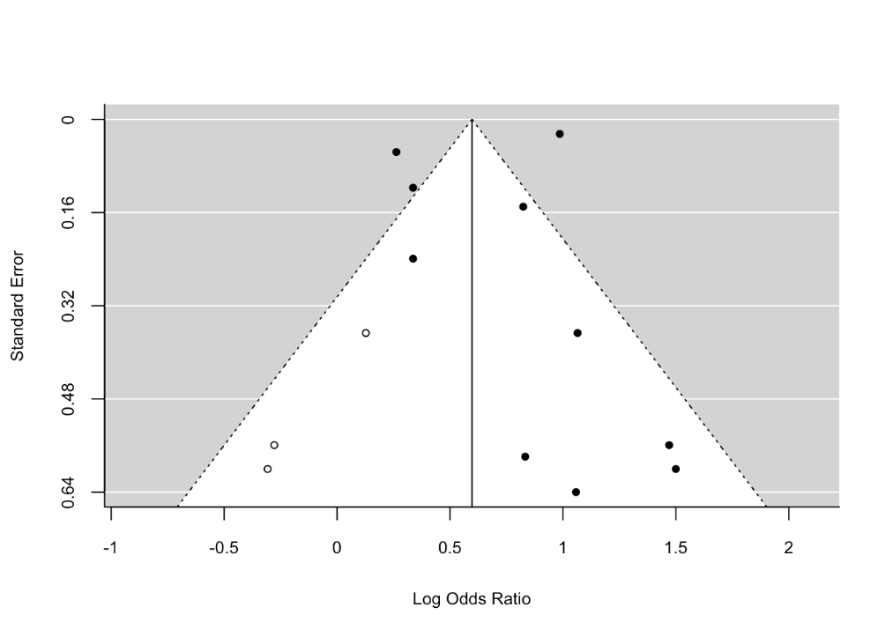

### Figure 58. Funnel plot: Period prevalence comorbidity between depression and alcohol dependence (unadjusted)

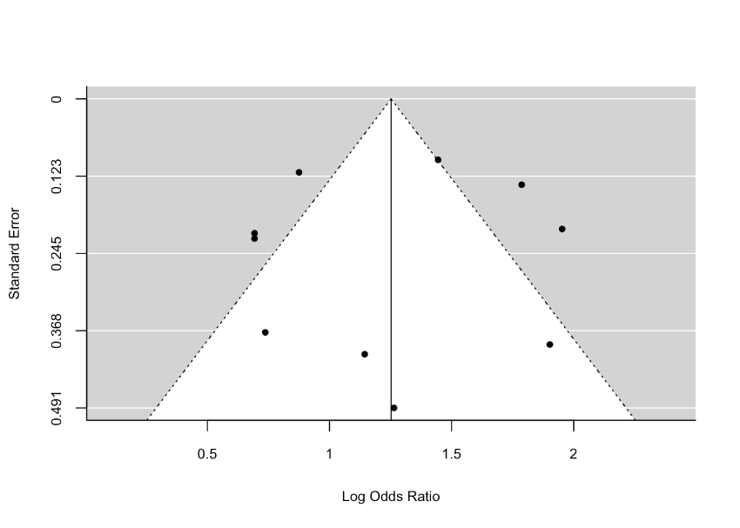

### Figure 59. Funnel plot: Lifetime comorbidity between depression and alcohol use disorder (unadjusted)

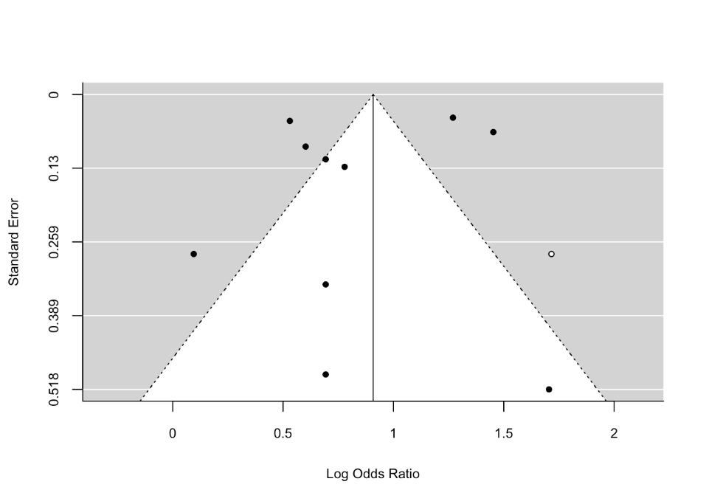

### Figure 60. Funnel plot: Period prevalence comorbidity between depression and alcohol use disorder (adjusted)

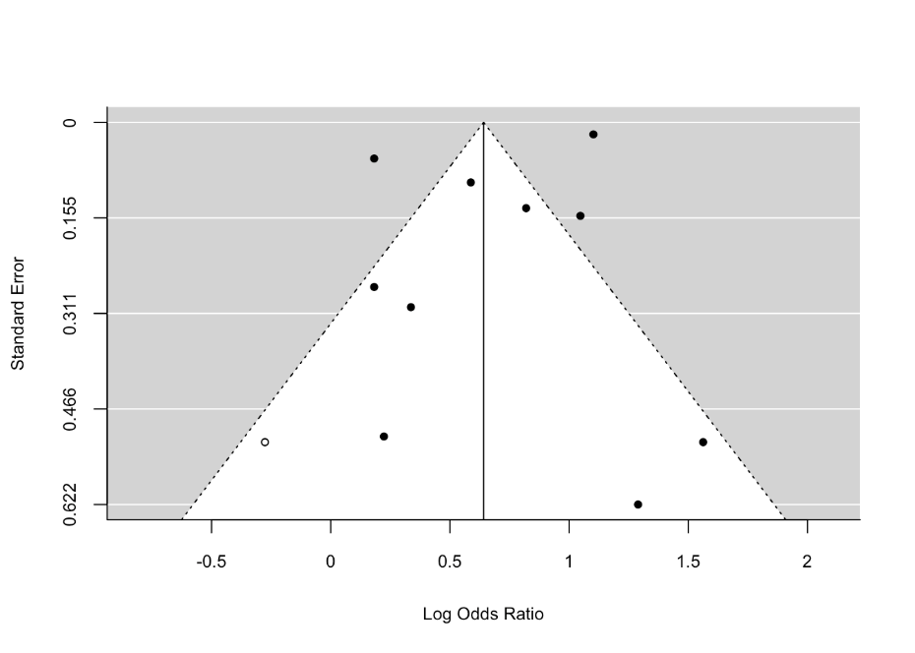

### Figure 61. Funnel plot: Lifetime comorbidity between broadly-defined depression and alcohol use disorder (adjusted)

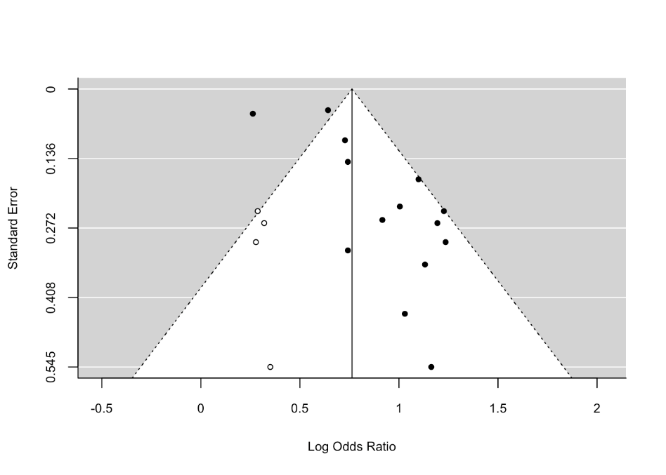

**Figure 62. Funnel plot: Lifetime comorbidity between broadly-defined depression and alcohol use disorder (adjusted)**

